AVRT5 Quick Use Guide
User discussion group: https://groups.yahoo.com/neo/groups/AP510/info
All firmware and configuration software download site address: http://avrtx.cn
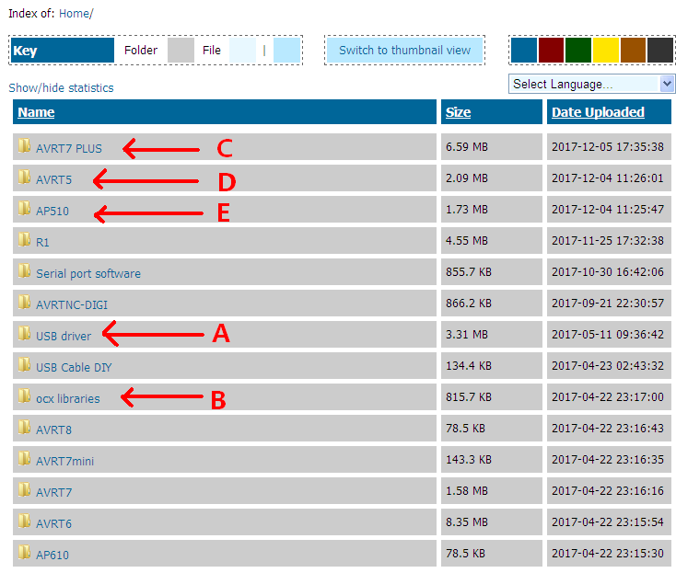
Location A., Download USB serial port driver。CH340 DRIVER.ZIP Install
Location B, Download the Microsoft VB/VC Runtime Library file，all ocx libraries.zip Install (right mouse button, select: install in administrator mode)
Location D. Download the User manual and software 20170403AP510 (delay 5s power up).zip
Program:
1，USB serial cable to connect PC and AVRT5,
2， Programming – Start with Unit “OFF”. Start Config program 20170121 AP510 config(fix model).exe. Set the COM port sequence ，Click “Read Config”. Press Power button until beep is heard. - Should respond with “…..”
3， Modify the data value, Click “write Config” to save。
4，Click “exit“, exit the program

Power On – Press and hold 1.5seconds until beep.
Power OFF – Press and hold 3 seconds until fast beeping starts, then release.

